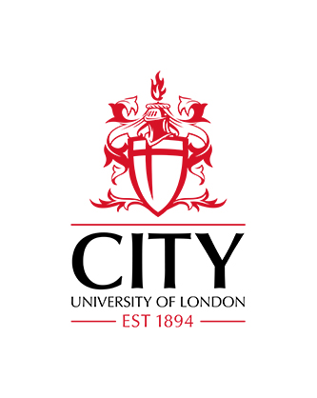
The Legacy of Mata Hari:
Women and Transgression

A one-day symposium
City, University of London
28 October, 2017

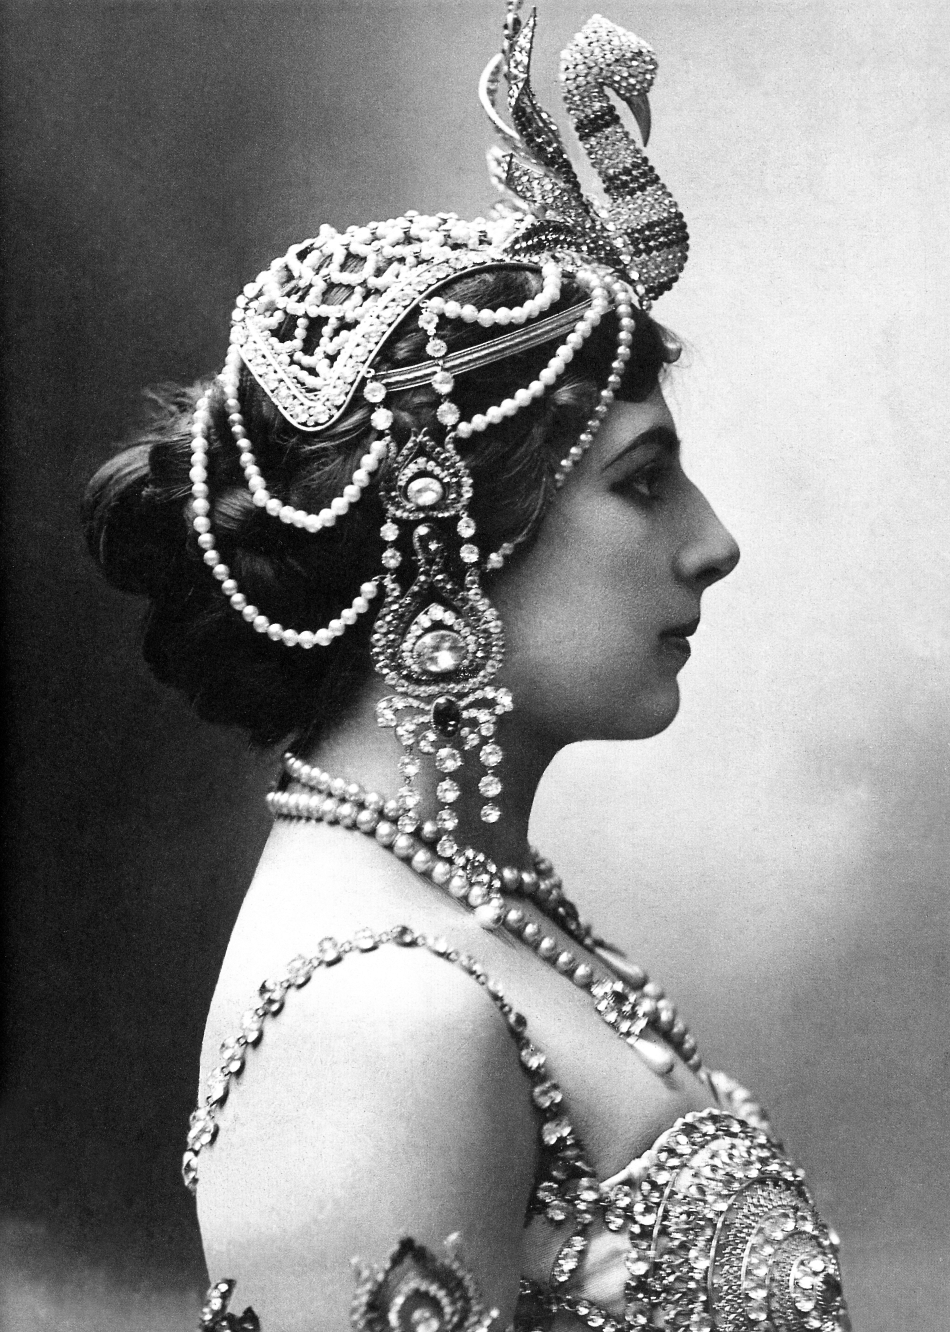
In October 1917, the woman known throughout the globe as Mata Hari was executed on espionage charges by a firing squad at Vincennes on the outskirts of Paris. Born Margaretha Geertruida Zelle (1876) in Leeuwarden, Holland, in 1905, she reinvented herself as the exotic dancer Mata Hari, trading on the fascination with colonial cultures in the fin de siècle. Although history has provided little evidence of her spying, Mata Hari’s French prosecutors condemned her as ‘the greatest female spy the world has ever known’, a vamp, a courtesan and a divorcee who had caused the deaths of 50,000 allied combatants.

On the centenary of her death, this symposium hosted by City, University of London acknowledges Mata Hari's significance as an icon of feminine seduction, political betrayal and female transgression into male spheres of influence. This multi-national, cross-disciplinary event drawing from history, politics, cultural studies, literary journalism, the visual and performing arts, museum studies, translation studies and feminist studies will bring together biographers, academics, novelists, performers and curators from the Fries Museum. Contributors will address the cultural multiplicity of the anxieties about women in the public sphere that Mata Hari symbolised both during the First World War and as enduring concerns. Speakers will discuss Mata Hari’s legacy in the identification of transgressive women today, especially those in the political sphere and those involved in global or domestic conflicts. Presentations from cultural historians on Mata Hari’s historic influence on dance, cinema and representation of the female body are also welcome.

We invite proposals for 20-minute papers or for conference panels on any aspect of Mata Hari and her legacy. Possible topics include but are not limited to:

- Mata Hari’s significance as a female icon during the First World War
- Representations of Mata Hari and female agents in theatre and film from the early 20th century
- Fictional and journalistic representations of female espionage agents
- Literary, cinematic, artistic and journalistic representations of transgressive women
- Representations of the female vamp and the performance of femininities
- The queer transgression of Mata Hari
- Post-colonialism and female erotic performance in the early twentieth century
- Women, war and espionage
- The creation and significance of female icons in the fin de siècle and beyond
- Female transgression and museum studies
- Cultural anxieties about female representation in political and domestic spheres

We hope to have media sponsors for the event and a number of UK outlets have already expressed interest in supporting the symposium. A publication based on the symposium is envisaged.

Please send proposals (300 words max. plus biographical paragraph of 200 words max.) to Dr Julie Wheelwright (julie.wheelwright.1@city.ac.uk) and Dr Minna Vuohelainen (minna.vuohelainen@city.ac.uk) no later than 30 May, 2017.

