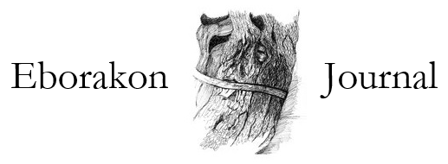

Call for Submissions
Eborakon
Issue 4

Eborakon is an annual poetry magazine based at the University of York, publishing new writers alongside established poets. The name is derived from the Brythonic for York, meaning “place of the yews”. We value writing that is rooted, both in the resonances of language as it has been used over the course of history, and in the evocation of place. We are nourished by the writers and critics who have preceded us, at the same time branching out to explore the future. Like the yew, for us poetry is mysterious and earthly, real matter that is potentially dangerous to savour.

We are delighted to announce that we are now open for submissions for Issue 4, which will go to press in the autumn. The best way to discover if your work is a fit for our magazine is to buy a copy or become a subscriber.

The deadline for all submissions is 2nd April 2017

Please send up to six poems or a one hundred line extract from a long poem in a single Word document, including page numbers and your name in the header. We aim to respond within 8-12 weeks, no feedback is given and all decisions are final. Where appropriate, we may publish some poems better suited to a digital format on our website. Unfortunately, we cannot remunerate work that appears in our pages. Eborakon can only consider previously unpublished material, including that sent in by literary agents. We accept concurrent submissions, but ask that you inform us promptly if you need to withdraw your poems. Please include a brief biography in your email.

Eborakon also dedicates several pages per issue to “the unexpected”: this can take the form of artwork, photography, collage, sections from libretti/words to music, a critical essay that is playful and creative, or anything we find outlandish, outré, original.

We welcome reviews of up to 1000 words on new poetry (collections published in the last twelve months) or monographs/studies of any aspect of poetry. Please approach us by email to pitch a review in the first instance. As with submissions of poems, we may ask to publish reviews through our website.

We prefer submissions by email to eborakonjournal@gmail.com, particularly if you are sending work from overseas, but also accept postal submissions addressed to:

The Editors
Eborakon
The Department of English and Related Literature
The University of York
YO10 5DD
United Kingdom

